Using Dijkstra’s Algorithm to Emulate a Standard Next-Hop Router System
CPSC 4317 Computer Networks
11/2/2024
Group Project Contributors:
Grayson Conger, Trevor Doss, Andrew Kalathra

Essence of Dijkstra
The essence of the Dijkstra algorithm is to read the shortest path to all other nodes from one start node. This is done using factors such as what nodes are already found as well as the cost to get there.
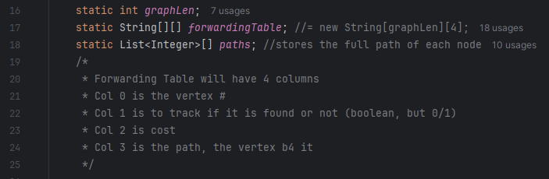
The algorithm first initializes the table, then starts at the start node. It sets column 1 to “1” to indicate it was found. It then reaches out to its neighbors (who have a positive weight) and update’s their cost and their path (column 2 and 3). After updating all it’s neighbors, the start node is then replaced with the next node that is not yet found and has the smallest cost. This cycle iterates until all nodes have been found, resulting in the smallest cost possible for each node.
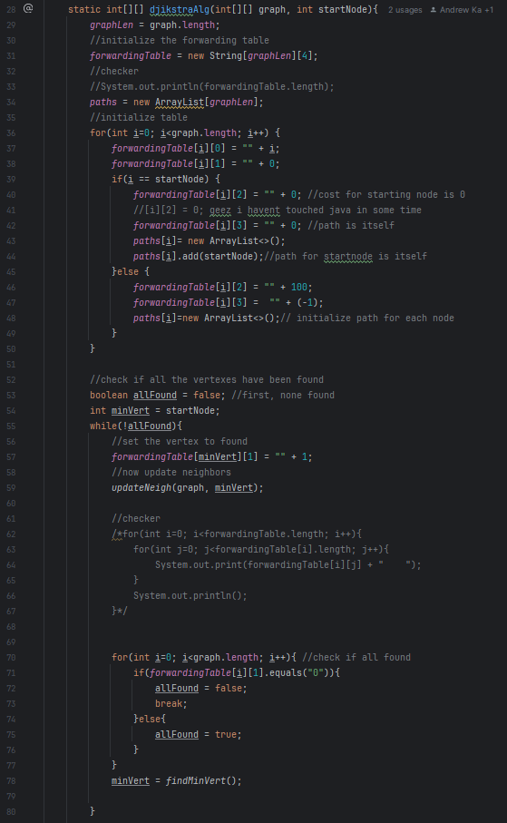

The dijkstraAlg method then returns a modified forwarding table with the following format:
Vertex # | Next Hop | Cost | Original Path
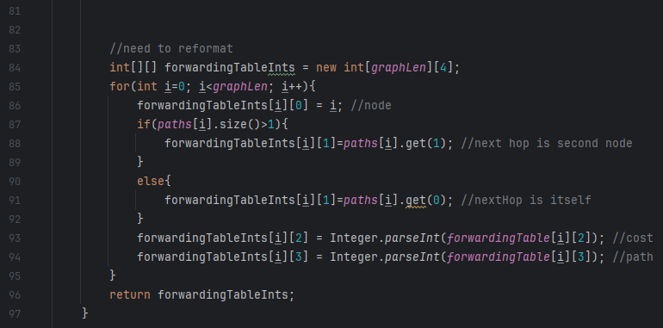

Part A: Returning a Data Forwarding Table
The main class starts by initializing the array that we are using.
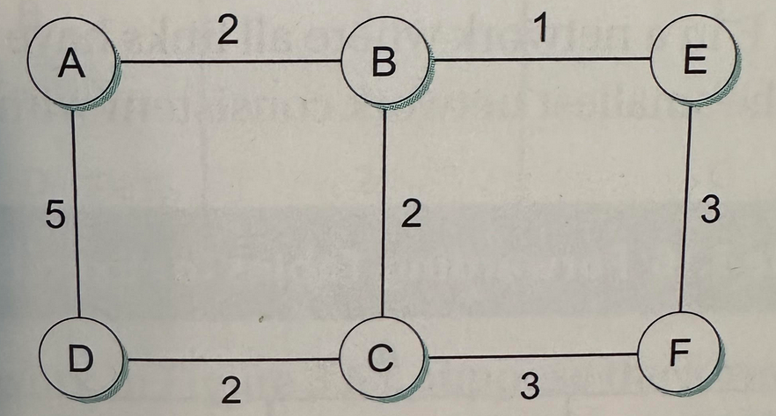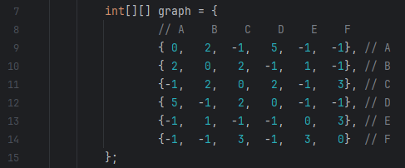
It then passes in this array and the starting node (though this is not entirely necessary) to the dijkstraAlg method found in the dijkstra.java class. Utilizing the result, we then just output the Forwarding Table in such a format:
Destination Vertex # | Next Hop | Cost
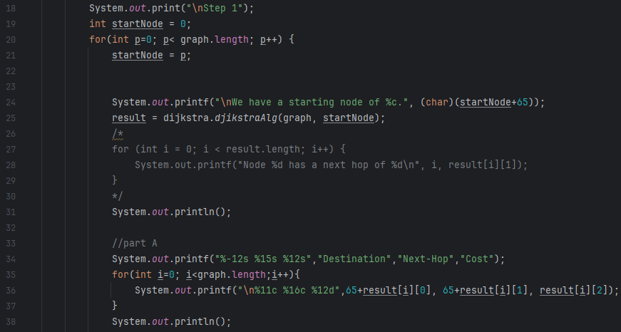
Output:
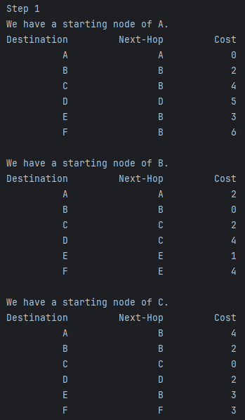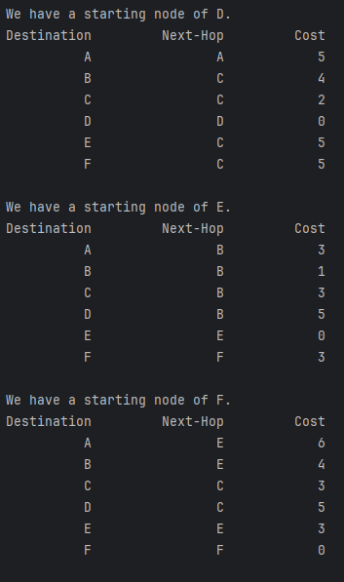

Part B: The Path from Node A to F
Simply using the Path, we can traverse the nodes to find the specific path to get from Node A to F. We use a stack as it is simple to implement as the path simply just builds from one node to the next until the destination node is reached. Following this, the stack can be popped incrementally to reveal the full path.
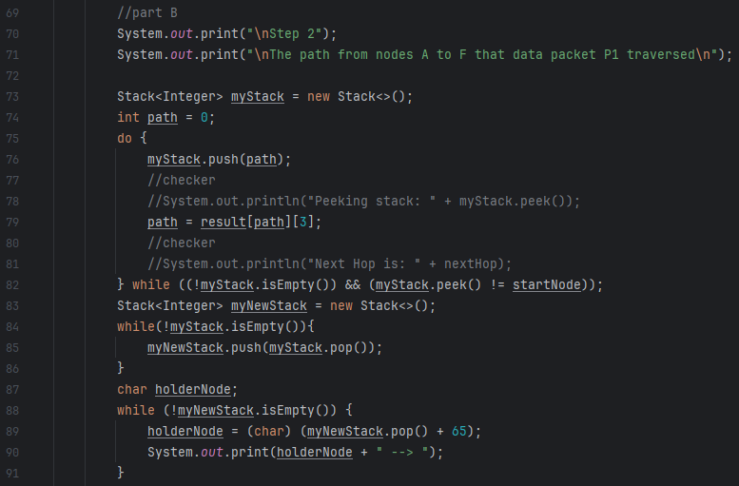
Output:
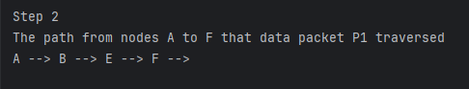

Part C: Breaking the Edge Between Nodes B and C
Since the graph was implemented using a 2D array, we simply need to change the weights for the locations [1, 2] and [2, 1] to “-1”. This graph uses “-1” to symbolize no connection between the nodes, “0” to symbolize itself, and a number for the specific weight of the edge.
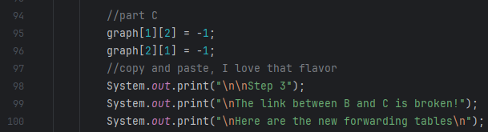
Following this, we simply just re-run the dijkstraAlg method to get an updated forwarding table.
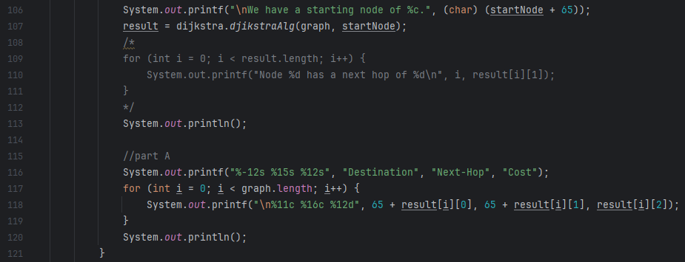
Output:
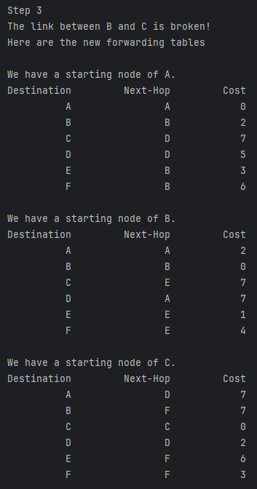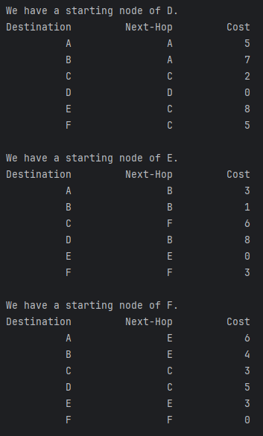

Part D: The Modified Path from Node A to F
Reutilizing the stack method from Part B, we can use the updated forwarding table to find the full path from Node A to F. Similar to Part B, the stack will start by pushing the start node and using the Path to push the next node until reaching the destination node. Following this, the stack is iteratively popped and printed to reveal the full path.
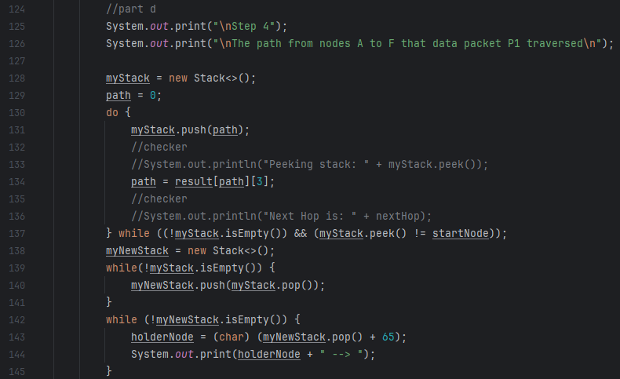
Output:
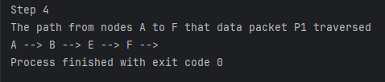

Conclusion
This program is rather simple in that it is easy to modify and understand. A key point that must be brought up is that the path is not the next hop. The next hop is the next node that must be travelled to reach the desired destination. The path may be the opposite, showing what came before rather than what comes next. Aside from this, using the costs and the next hops gives a good indication of what is going on using the Dijkstra algorithm to provide the most efficient paths.

References
- “Dijkstra Shortest Path.” Dijkstra Visualzation, www.cs.usfca.edu/~galles/visualization/Dijkstra.html. Accessed 9 Nov. 2024.
- GeeksforGeeks “Find Shortest Paths from Source to All Vertices Using Dijkstra’s Algorithm.” GeeksforGeeks, 6 Aug. 2024, www.geeksforgeeks.org/dijkstras-shortest-path-algorithm-greedy-algo-7/.
- “Graphs as Sets.” Graphs in Computer Science, web.cecs.pdx.edu/~sheard/course/Cs163/Doc/Graphs.html. Accessed 9 Nov. 2024.

